Hackathon Project Phases Template for the StudyMate project.

Hackathon Project Phases Template
Project Title:
StudyMate
Team Name:
Team TripleByte
Team Members:
- Jahnavi Priya P
- Lahari M
- Manmitha M

Phase-1: Brainstorming & Ideation
Objective:
Develop an AI-powered Q&A expert tool using Gemini API,IBM watsonx , FAISS.
Key Points:
- Problem Statement:
  - Many users struggle to study on their own with limited resources.
  - Users also need a guidance on study tips, retrieving of information in an efficient way.
- Proposed Solution:
  - An AI-powered application using Gemini API,IBM watsonx, FAISS to help user prepare for tests, understand concepts, increases curiosity.
  - The application offers tips, acts as a study and motivation companion.
- Target Users:
  - Students in need for a better platform for accessing and generating information.
  - Teachers who want to explain concepts in an efficient and exciting manner.
  - Intellectual Explorers interested in learning new concepts.
- Expected Outcome:
  - A functional AI-powered study material application that provides information based on the material uploaded, generates flashcards and quizzes.

Phase-2: Requirement Analysis
Objective:
Define the technical and functional requirements for the StudyMate Application.
Key Points:
- Technical Requirements:
  - Programming Language: Python
  - Backend: Gemini API, IBM watsonx, FAISS
  - Frontend: Streamlit, CSS, HTML
  - Database: Not required initially (API-based queries)
- Functional Requirements:
  - Ability to extract information using FAISS.
  - Display specifications, reviews, and comparisons in an intuitive UI.
  - Provide real-time study tips based on user’s needs.
  - Allow users to save their work and notes
- Constraints & Challenges:
  - Ensuring real-time updates from Gemini API.
  - Handling API rate limits and optimizing API calls.
  - Providing a smooth UI experience with Streamlit.

Phase-3: Project Design
Objective:
Develop the architecture and user flow of the application.
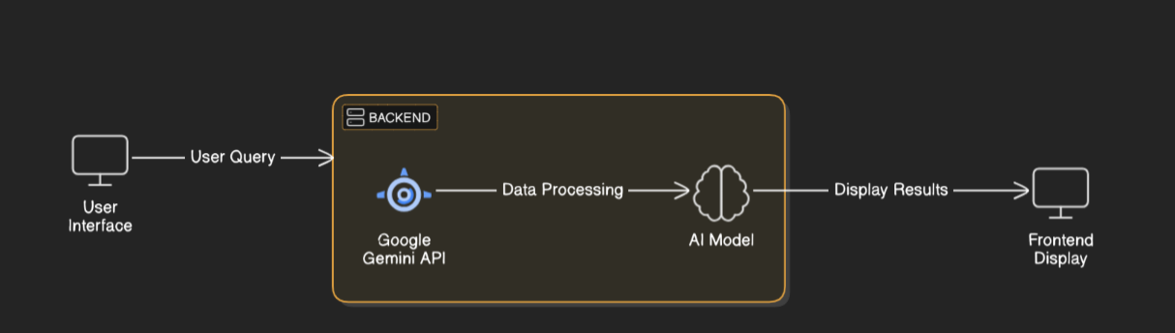
Key Points:
- System Architecture:
  - User enters vehicle-related query via UI.
  - Query is processed using Google Gemini API.
  - AI model fetches and processes the data.
- The frontend displays the different types of files from which the user can access the information, comparisons, flashcards generation.
- User Flow:
  - Step 1: User uploads a pdf or document.
  - Step 2: The backend calls the Gemini Flash API to retrieve information in the uploaded file.
  - Step 3: The app processes the data and displays results in an easy-to-read format including flashcards.
- UI/UX Considerations:
  - Minimalist, user-friendly interface for seamless navigation.
  - Filters for navigation, profile.
  - A simple ocean blue colour palette for better user experience.

Phase-4: Project Planning (Agile Methodologies)
Objective:
Break down development tasks for efficient completion.
Sprint | Task | Priority | Duration | Deadline | Assigned To | Dependencies | Expected Outcome
Sprint 1 | Environment Setup & API Integration | 🔴 High | 5 hours (Day 1) | End of Day 1 | Lahari | Google API Key, IBM watsonx Python, Streamlit setup | API connection established & working
Sprint 1 | Frontend UI Development | 🟡 Medium | 2 hours (Day 1) | End of Day 1 | Jahnavi Priya | API response | Basic UI with input fields
Sprint 2 | Research and required functionalities | 🔴 High | 1 hours (Day 1) | Mid-Day 1 | Manmitha | API response, UI elements ready | Search functionality with filters
Sprint 2 | Error Handling & Debugging | 🔴 High | 3 hours (Day 2) | Mid-Day 2 | Lahari & Jahnavi | API logs, UI inputs | Improved API stability
Sprint 3 | Testing & UI Enhancements | 🟡 Medium | 2.5 hours (Day 2) | Mid-Day 2 | Manmitha | API response, UI layout completed | Responsive UI, better user experience
Sprint 3 | Final Presentation & Deployment | 🟢 Low | 1 hour (Day 2) | End of Day 2 | Entire Team | Working prototype | Demo-ready project

Sprint Planning with Priorities
Sprint 1 – Setup & Integration (Day 1)
(🔴 High Priority) Set up the environment & install dependencies.
(🔴 High Priority) Integrate Google Gemini API,IBM watsonx
(🟡 Medium Priority) Build a basic UI with input fields.
Sprint 2 – Core Features & Debugging (Day 2)
(🔴 High Priority) Implement search & comparison functionalities.
(🔴 High Priority) Debug API issues & handle errors in queries.
Sprint 3 – Testing, Enhancements & Submission (Day 2)
(🟡 Medium Priority) Test API responses, refine UI, & fix UI bugs.
(🟢 Low Priority) Final demo preparation & deployment.

Phase-5: Project Development
Objective:
Implement core features of the StudyMate application.
Key Points:
- Technology Stack Used:
  - Frontend: Streamlit,CSS,HTML
  - Backend: Google Gemini Flash API,IBM watsonx
  - Programming Language: Python
- Development Process:
  - Implement API key authentication and Gemini API integration.
  - Develop information comparison and maintenance tips logic.
  - Optimize search queries for performance and relevance.
- Challenges & Fixes:
  - Challenge: Delayed API response times.
Fix: Implement caching to store frequently queried results.
  - Challenge: Limited API calls per minute.
Fix: Optimize queries to fetch only necessary data.

Phase-6: Functional & Performance Testing
Objective:
Ensure that the StudyMate Application works as expected.
Test Case ID | Category | Test Scenario | Expected Outcome | Status | Tester
TC-001 | Functional Testing | Testing the frontend UI | The application should have features like uploading of documents or pdf files, flashcard and quiz generation | ✅ Passed | Jahnavi
TC-002 | Functional Testing | Backend testing of the code | Information accessing using API | ✅ Passed | Lahari
TC-003 | Performance Testing | API response time under 500ms | API should return results quickly. | ⚠ Needs Optimization | Manmitha
TC-004 | Bug Fixes & Improvements | Fixed incorrect API responses. | Data accuracy should be improved. | ✅ Fixed | Jahnavi
TC-005 | Final Validation | Ensure UI is responsive across devices. | UI should work on mobile & desktop. | ❌ Failed - UI broken on mobile | Manmitha& Lahari

Final Submission
- Project Report Based on the templates
- Demo Video (3-5 Minutes)
- GitHub/Code Repository Link
- Presentation

